NAME: ………………………….. CLASS: …………………..

MIDTERM

READING 1
SPAM MESSAGING
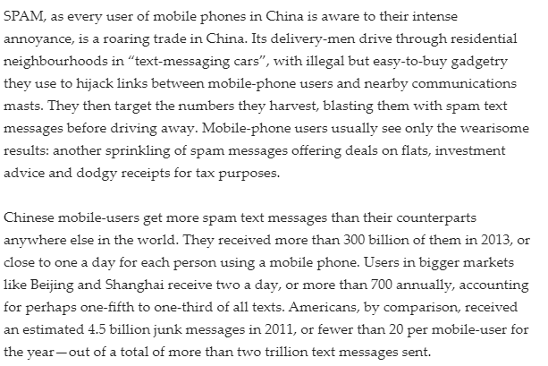
Question 1-6: Decide if the following questions are True, False or Not give
1. In China, SPAM text messaging is a successful business.
2. People's phone numbers are collected through the use of technology which can not be readily bought.
3. In no other country do people receive more Spam texts than in China.
4. In 2013, the number of Spam texts increased considerably to reach 300 billion.
5. The majority of all texts received in Shanghai and Beijing are SPAM.
6. In 2011, Americans sent more texts than anywhere else in the world.

READING 2:
First test to predict Alzheimer's
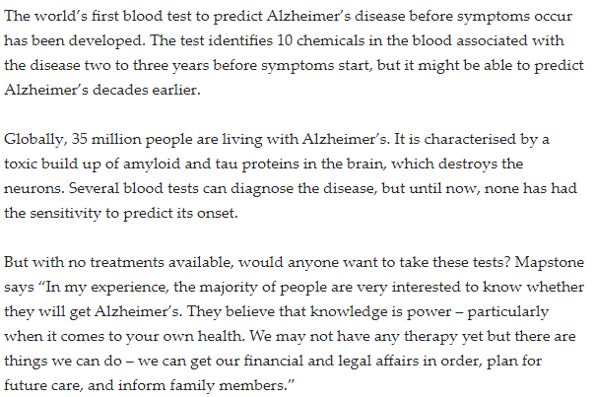
Questions:
Choose the correct letter A-C
1. The test can predict Alzheimer's ………
A. two or three years before the illness begins.
B. two or three years form the start of the symptoms.
C. a decade before.
2. This test is the first blood test which can …………
A. cure Alzheimer's
B. estimate the start of the disease
C. diagnose the disease.
3. Mapstone believes that…………
A. this test will help people understand Alzheimer's
B. people want to know about their health
C. people want to power.

